## Merchant

Demo date: Sep 25, 2024  
Scoping start date: Sep 20, 2024

MSA Signature Date: Sep 26, 2024  
Onboarding Kick Off Date: Nov 1, 2024

[If Exists] Opt Out Date: Apr. 1st, 2025  
Go Live Date: Dec 1, 2024

GTM POC: Nick  
Implementation POC: Royce

ERP: QBO

Tax Integration: QBO Hard Coded Taxes

### 

### Key people at Merchant

### 1 person Finance team. Director of Finance: Jordan Harris

### 

| Notes Sections [Ops International Team to Ignore] *(AE/ Implementation to fill)*   * Info on how merchant bills   + Moving to all Annual, still have Monthly for a majority of their customers   + 10% of their customers start getting billed on Go Live   + Subscription and implementation * Is there any important merchant relationship information?  1) What is the merchant temperament? * Jordan is smart and experienced finance leader. Very easy to work with, but is somewhat of a skeptic 2) Is there a key POC: (i.e.: who is the buyer/decision maker?) * Jordan Harris - Director of Finance 3) What are the Tabs features that the key POC cares about? * Stripe, QBO, and Pandadocs integration. Invoicing rolling up to reporting (Rev Rec, ARR, CARR, MRR, Trends). Automating subscription billing. Opportunity to change pricing. Key Term extraction |
| --- |

### 

### Company summary *(AE to fill)*

Alvys is a cloud-based transportation management system with high-tech automation. Alvys provides a logistics platform designed to streamline operations for carriers, brokers, and hybrid operations. The software integrates various tools for dispatching, driver management, billing, compliance, load management, tracking, and analytics. It aims to enhance efficiency and reduce overhead costs by offering features like automated load creation, real-time load tracking, and comprehensive safety and maintenance monitoring.

Goals (North star)  
*(AE/ Implementation to fill)*

What is the merchant's goal? What pain are we solving? Why are they buying Tabs?

One platform for Revenue automation tying together their point solutions

Automate invoicing

Reporting

Collections  
  
Is there an opt out clause? If so, what is the merchant looking for so they do not exercise it?  
Opt out after 6 months (Apr. 1st, 2025). Hesitancy that Tabs will actually work with his process and across his systems

### Billing model *(AE/ Implementation to fill)*

* Are there unique things about the customer creation process for this merchant?
  + 10% of customers are billed on Go Live, which is tracked in HS. Other 90% are billed 60 days from contract signature regardless of go live.
  + All contracts are different (ie. annual vs monthly and $$ amounts)
  + Starting to incorporate overages into billing
* Information on how merchant bills
  + Monthly and annual. In stripe today with subscriptions
* How contract is broken up
  + Effective Date vs Start Date
* One off things to know about the merchant

### Contract Processing Steps *(Implementation/Success to fill)*

1. Steps to process  
   TWO types of contracts - please refer to the appropriate section based on the contract. This only impacts the revenue recognition portion:
   1. **Subscription Carrier Plan**

Contracts **do not** reference an “Anticipated Go-Live” date

Example:

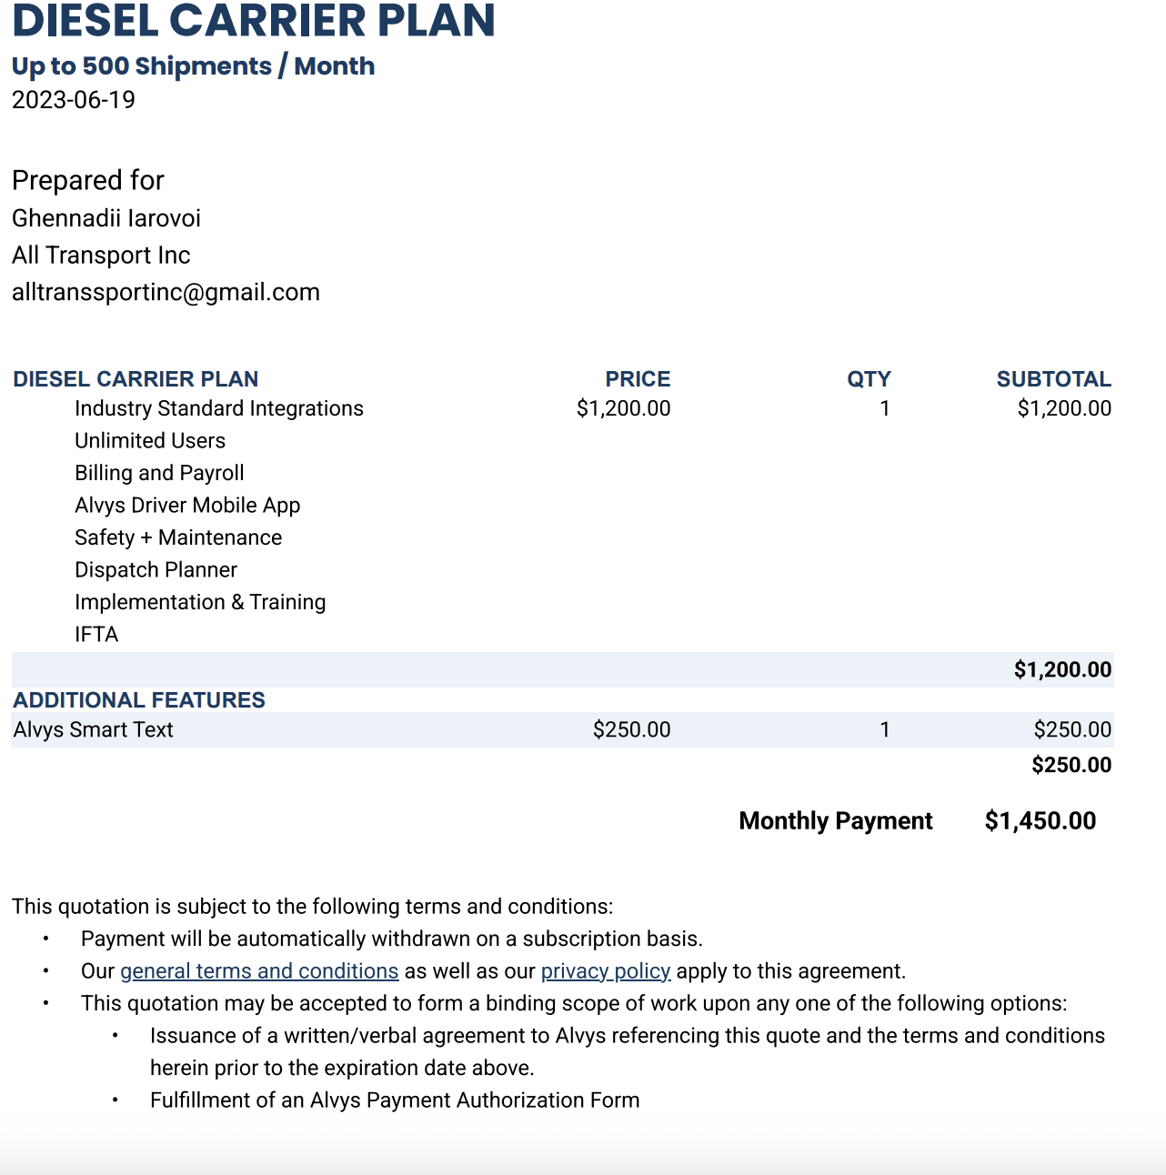

* 1. **Anticipated Go-Live**

For any contract that references a “Anticipated Go-Live Date”.

Contracts look like this:



Or this:



*If you have questions, you can reference these five contracts as a guide:*

*8bdfd688-7b22-4041-a374-8ffa3c49e0bf*

*900415bd-38fb-4770-87e6-650b127e7bb8*

*7baba1f6-0963-4b90-b5e5-31ba07ece52f*

*F0ff2929-4e87-458e-8e95-15b9012fbf4b*

*C5720058-bf00-4a91-92be-9c76687c739e*

1. **Subscription Carrier Plan**

**Service start date:** use the date listed on the top left corner of the document



**Months of Service:** default 12 months, unless stated otherwise

* **Exception:** one-time implementation fees should be 0

1. **Anticipated Go-Live**

**Service Start Date:**

* If it is a Master Services Agreement (MSA), use the effective date of the agreement
* If not a MSA, there should be an “Agreement Term Start Date” - use that

**Months of Service:**

* If it is a Master Services Agreement (MSA), use number of months (nearest whole number) that gets you from the “Effective Date” to the **end** of the “Initial Term”
* Pay attention that the end of the Initial Term is based on the “Go-Live” date and **NOT** the “Effective date”
* If not a MSA, use number of months (nearest whole number) that gets you from the “Agreement Term Start Date” to the “Agreement End Date”



**Item and Price** - should be processed in the same way regardless of whether the contract is **A. or B.**

* One for every line item
* **Item Name:** use item name for associated products
* Example for **A.** items below would be “Diesel Carrier Plan” and “Alvys Smart Text”



* Example for **B.** items below would be “Per Load Pricing”, “Managed EDI - Premium/Diesel”, “EDI Trading Partner”, and “Getting Started Package - Enterprise”

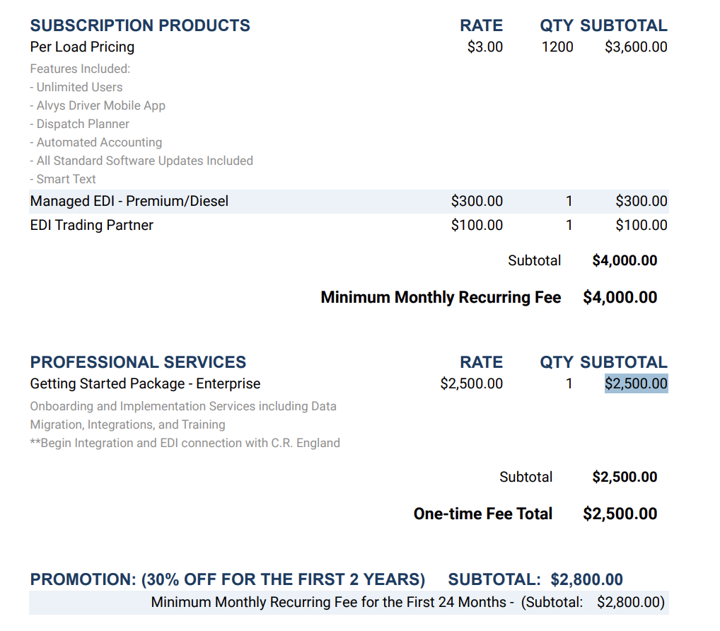

* **Item Description:** Copy list of included products under the product
* **Integration Item:** search for the item name and find the closest match; if there are no matches, leave it blank

**Billing Terms** - should be processed in the same way regardless of whether it is an **A. or B.** contract except for the **billing start date**

* **Billing Type:** flat price
* **Total Price:** use the price listed in the column circled in red above. If there is a discount, you can use the price net of the discount.
  + Any discounts should be made in the same BT and **not** as a separate billing term
* **Billing start date:** 
  + **For A.** same as service start date
  + **For B.** use the anticipated go-live date (circled in purple in example **B.**)
    - **Exception:** sometime there is a one-time upfront investment on non-MSA contracts that are billed on the “agreement term start date”



* **Frequency:** usually 1 month, unless stated otherwise
* **Period:** however long the term is divided by the frequency; default term is 1 year
  + For example, if the term is 1 year → 12 months (term) / 1 month (frequency) = 12
    - make sure units are the same i.e. months
* **Net Terms:** default 0 unless stated otherwise
  + **Exception:** one-time implementation fees are usually net 3 (please double check)
* **Billing Timing:** bill in advance, due start of period
  + **Exception:** one-time implementation fees are billed first of period

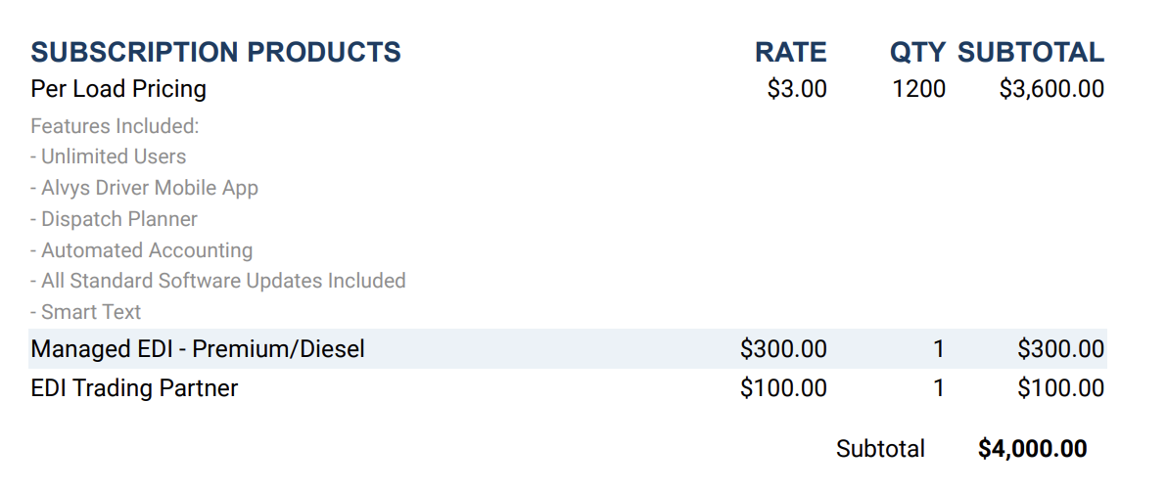

**ADDITIONALLY!!** One more step for type **B. (Anticipated Go-Live)** contracts:

1. You must create another revenue schedule/billing term for unit based billing if they go above their contracted amount
   1. **Exception:** sometimes non MSA forms do not have a per-load pricing product. In this case you don’t have to create this usage based BT

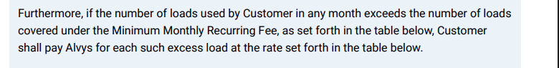

In this example:

You would create a billing term labeled “Additional Per Load Pricing” for any loads used above 1,200. The instructions above still apply except this BT should be

1. Billed first of next (period arrears)
2. Be a tier unit price - the first level up to the QTY (1,200) included would be 0. The second level above the QTY (1,201+) would be charged at the rate listed per unit ($3)
3. Event to track: additional load

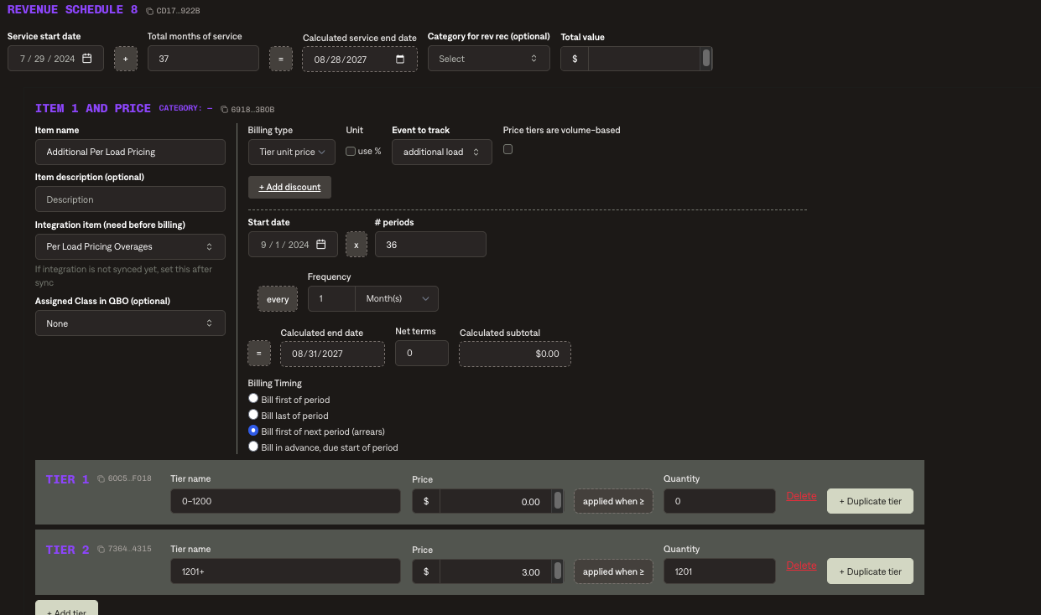

1. Anything to ignore in contracts?
2. Specifics processing things the merchant has requested that may differ by contract (e.g. always back-date invoice date to final day of the month)
3. Default Service Term
   1. If None Listed, Ops Default is 1 Year
4. Default Net Payment Terms
   1. If None, Ops Default is 30
5. Default Billing Frequency
   1. If None Listed, Ops Default is Monthly
6. How do we handle taxes as a line item?
   1. If None Listed, Ops Default is every tax line item becomes a BT

### Events Processing (if necessary) *(Implementation/Success to fill)*

* Any important information on events billing

Integration Items Processing (if necessary)  
*(Implementation/Success to fill)*

* What are the instructions for assigning integration items?
* Example: All Statsig integrations items should be labeled as “Sales”
* Example: All “Pinata” integration items should be labeled as “Software Subscription Bundle” unless otherwise noted by Merchant

Post Processing Communications (if necessary)  
*(Implementation/Success to fill)*

* Does the Ops Team need to notify anyone on the team re: completion of processing batches in Implementation or Active phase?
* Who needs to be notified and when?
  + Example:
    - Who: Customer Success [Azmat Aziz] needs to be notified
    - Where: Messari internal merchant channel
    - When: contracts are processed [Merchant Phase: Active]

### Customer Information *(Implementation/Success to fill)*

* Any important information on specifics customers of this merchant
  + Special memo’s certain invoices require
  + Invoice changes due to merchant/customer relationship

### Feature Requests *(AE/Implementation/Success to fill)*

* Automating Go Live to start billing for his 10% of customers from HS

### Rewatch Calls *(AE/Implementation/Success to fill)*

* September 20th, 2024 - Disco Call
  + https://tabs.rewatch.com/video/m9a8vblkwrcah0d2-tabs-intro-alvys-september-20-2024
* September 25th, 2024 - Custom Demo
  + https://tabs.rewatch.com/video/vef52hmirdtjilpn-alvys-tabs-custom-demo-september-25-2024